Exercici a entregar : ACTUALITZAR comparativa entre dos CPU de la teoria anterior fent servir CPUs del 2023.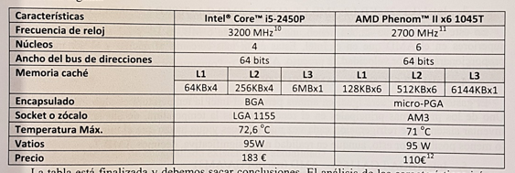

|  |  |  |
| --- | --- | --- |
| Características | Intel Core i5-13400 | AMD Ryzen 5 7600 |
| Frecuencia de reloj | 4.60 GHz | 3.8 Ghz |
| Núcleos | 10 | 6 |
| Ancho de bus de direcciones | 64 bits | 64 bits |
| Memoria caché | |  |  | | --- | --- | | L1 | L2 | | 20 MB | 9.5 MB | | |  |  |  | | --- | --- | --- | | L1 | L2 | L3 | | 384 KB | 6MB | 32MB | |
| Encapsulado | - | - |
| Socket o zócalo | FCLGA1700 | AM5 |
| Temperatura Máx. | - | 95ºC |
| Vatios | 65W | 65W |
| Precio | 221€ | 250€ |